

Topic test 1
Name: __________________________________

Chapter 3: Functions and sketching graphs

- Time allowed: 45 minutes
- CAS calculators may be used.
- Part A: 5 multiple-choice questions (5 marks).
- Part B: 8 short-answer questions (16 marks).
- Part C: 2 analysis questions (6 marks).
Part A
Multiple-choice questions
5 multiple-choice questions
1 mark each: 5 marks
Circle the correct answer.
1 What is the composite function 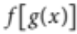 given that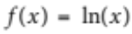 and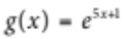?
A 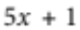
B 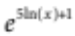
C 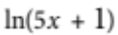
D 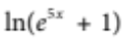
E 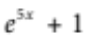
[1 mark]
2 Which of the following relations is NOT a function?
A 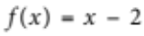
B 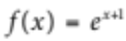
C 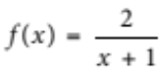
D 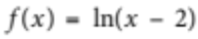
E 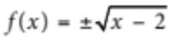
[1 mark]

3 Write the inverse function of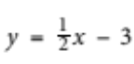.
A 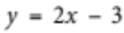
B 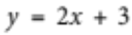
C 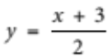
D 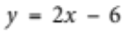
E 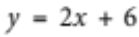
[1 mark]
4 Sketch the function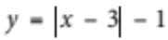.
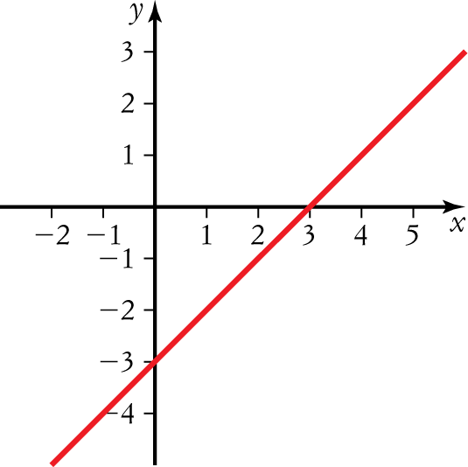
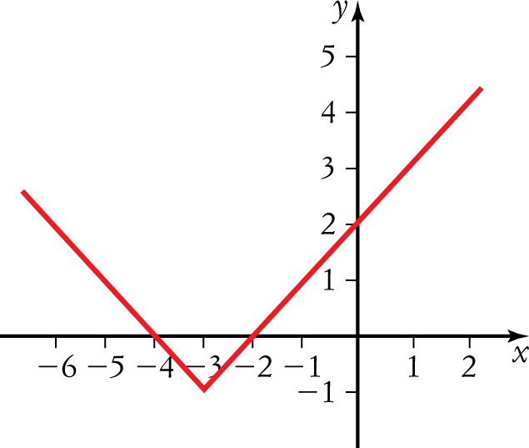
A D

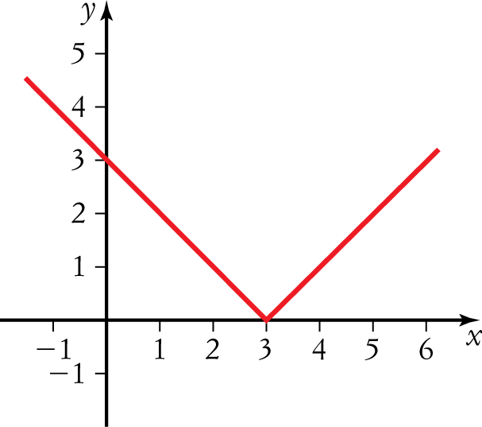
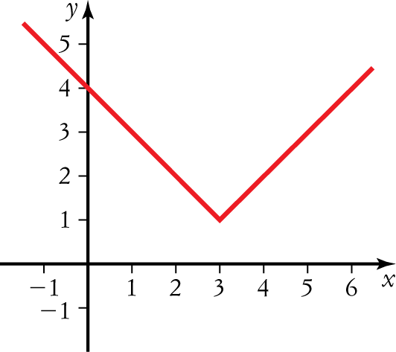
B E

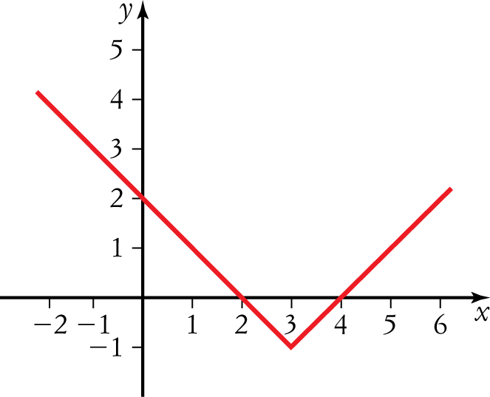
C

[1 mark]

5 Which graph represents the reciprocal function of 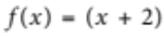?
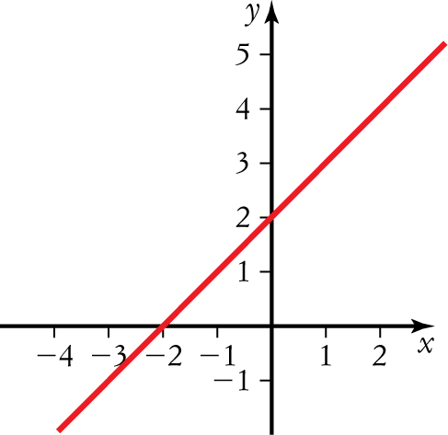
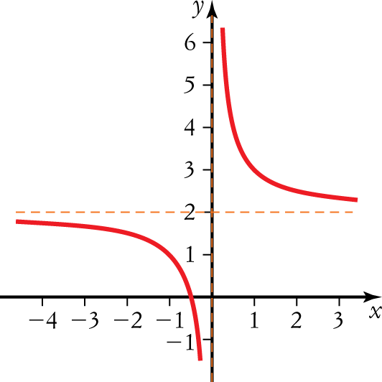
A D

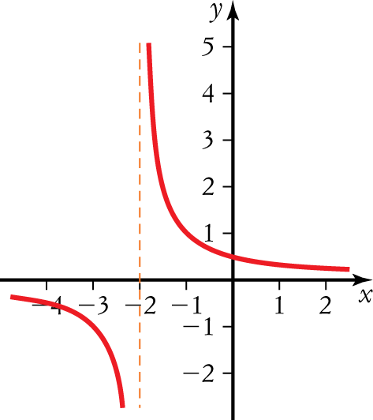
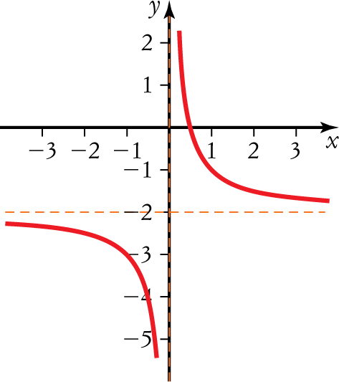
B E

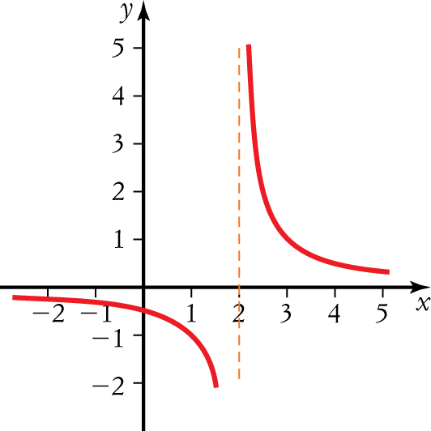
C

[1 mark]

Part B
Short-answer questions
8 short-answer questions
16 marks
Show your working where appropriate.
1 Sketch the graph of 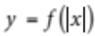 given that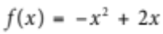.
[2 marks]
2 Sketch the graph of 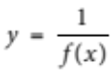 given that. Write the domain of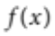.
[2 marks]
3 Sketch the graph of 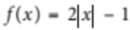. Write the range of.
[2 marks]
4 Sketch the graph of 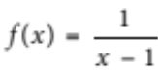. Write the domain of.
[2 marks]
5 Sketch the graph of 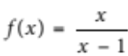. Write the range of.
[2 marks]
6 Sketch the graph of 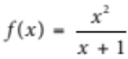. Write the domain of.
[2 marks]
7 Sketch the graph of 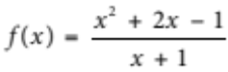.
[2 marks]
8 Write a rational function for the following graph.
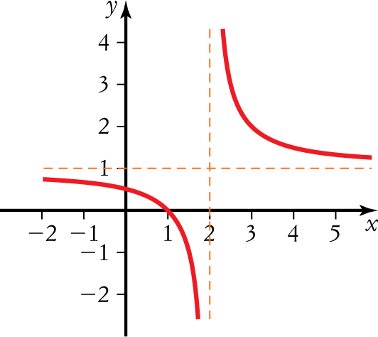
[2 marks]

Part C
Analysis questions
2 analysis questions
6 marks
Show your working where appropriate.
1 Solve the inequality, 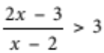 by sketching functions.
[3 marks]
2 The time (t) it takes for sound to travel one kilometre can be modelled by 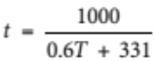, where T is the air temperature in degrees Celsius and t is in seconds.
a How long does it take for sound to travel 10 kilometres when the air temperature is 25C?
b Graph the given function to estimate the air temperature when it takes 3 seconds to hear a lightning strike
1 kilometre away.
[3 marks]
[Total marks: 27]

Answers
Part A – Multiple-choice questions [1 mark each]
1 ,
 A [1 mark]
2 ,
 E [1 mark]
3 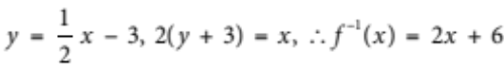,
 E [1 mark]
4 ,
 C [1 mark]
5 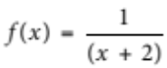,
 B [1 mark]
Part B – Short-answer questions
1 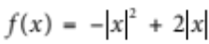
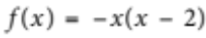
Intercepts at (22, 0), 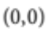 and 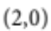 [1 mark]
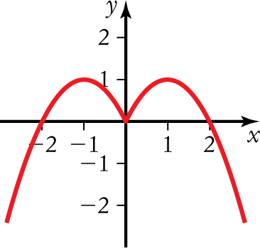
[1 mark]
[2 marks altogether]
2 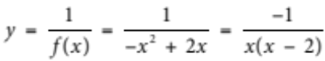
Domain: 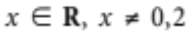 [1 mark]
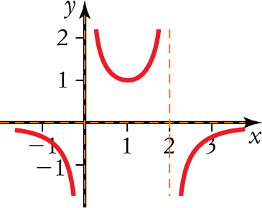
[1 mark]
[2 marks altogether]
3 ,
Range: 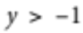 [1 mark]
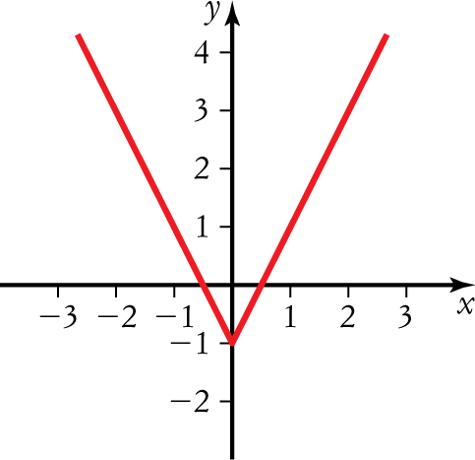
[1 mark]
[2 marks altogether]
4 ,
Domain: 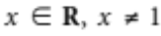 [1 mark]
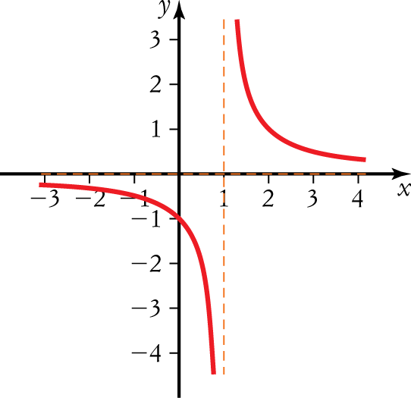
[1 mark]
[2 marks altogether]
5 ,
Range: 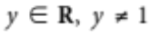 [1 mark]
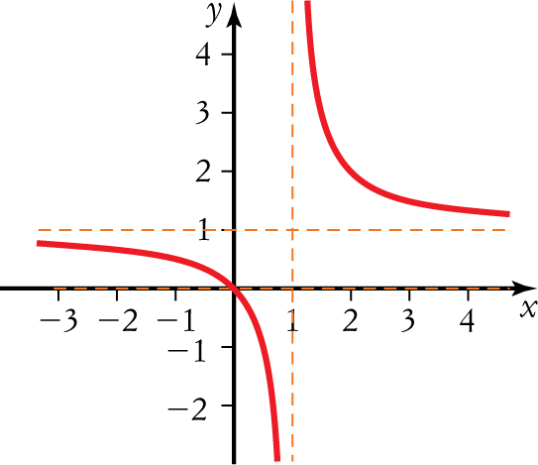
[1 mark]
[2 marks altogether]
6 ,
Domain: 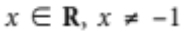 [1 mark]
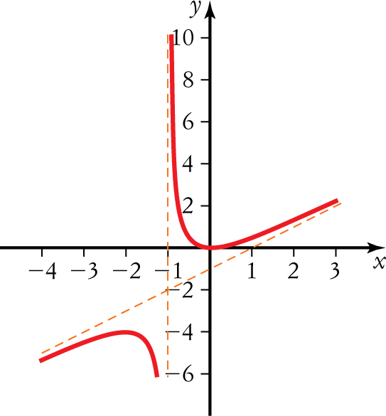
[1 mark]
[2 marks altogether]
7
Asymptotes [1 mark]
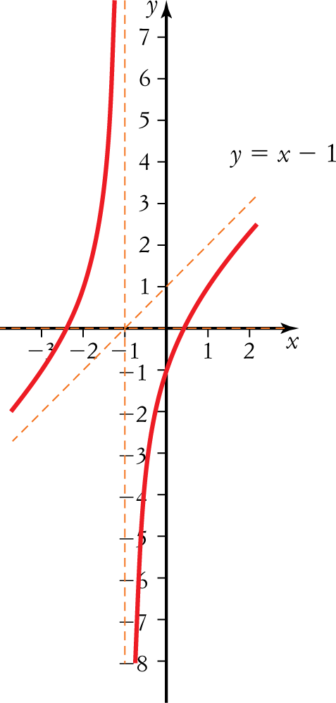
[1 mark]
[2 marks altogether]
8 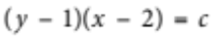,
substitute 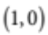, [1 mark]
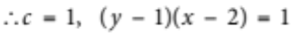
or 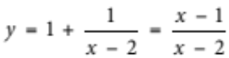. [1 mark]
[2 marks altogether]
Part C – Analysis questions
1 , [1 mark]
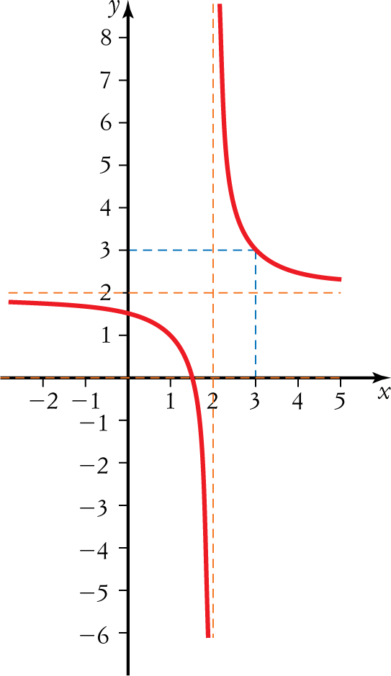
[1 mark]
Solution is 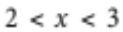. [1 mark]
[3 marks altogether]

2 a 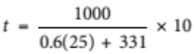 ≈ 28.9 seconds [1 mark]
b 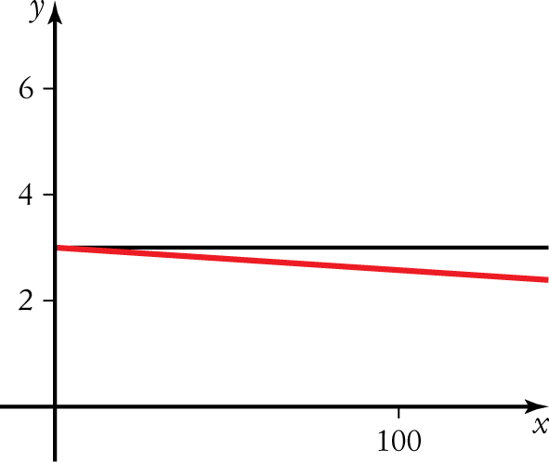
Looking more closely,
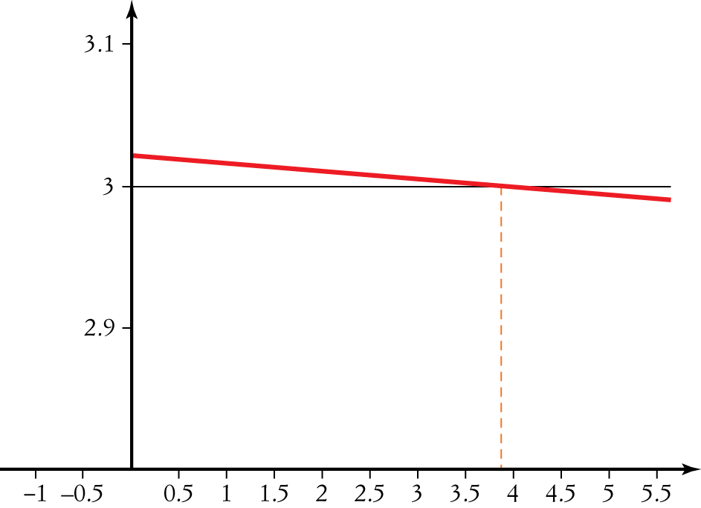
[1 mark]
The air temperature is approximately 3.8C. [1 mark]
[3 marks altogether]

